

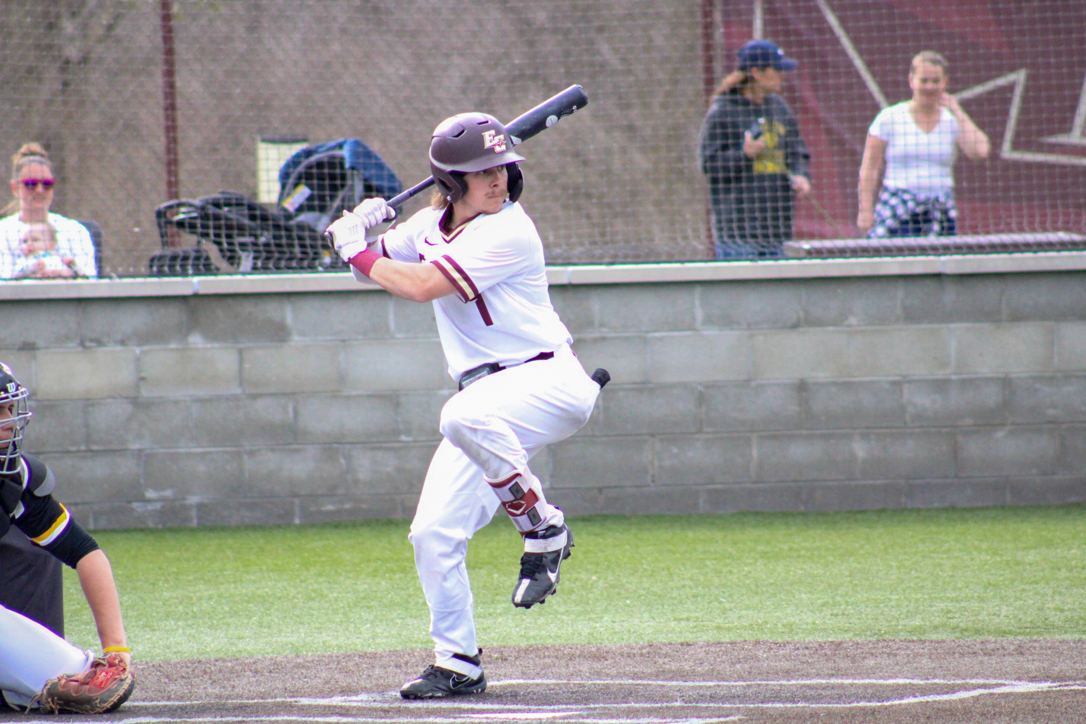

For More Information Contact:

Steve Sakosits, Head Baseball Coach
(765)983-1730 or sakosst@earlham.edu
Camp website-earlhambaseballcamps.com


FALL PROSPECT CAMP

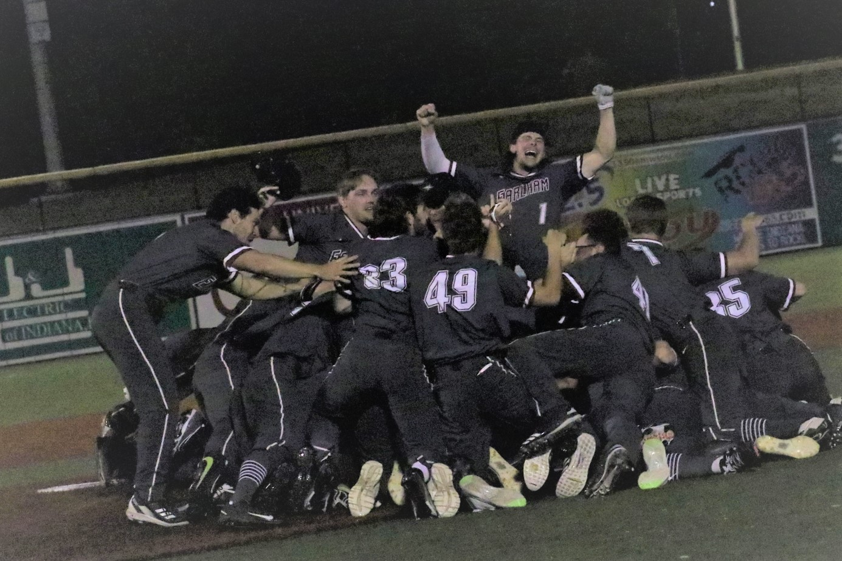

Sunday, August 17th, 2025
9:00am - 1:00pm
SADLER STADIUM
Cost: $60
If received before August 9th, 2025
$100 after registration date or walk-up
*Enrollment is limited to ensure quality instruction.

For More Information: (765) 983-1730
E-mail: sakosst@earlham.edu
earlhambaseballcamps.com
Facebook/Twitter-EarlhamBaseball

0141
Earlham College Baseball
Attn: Steve Sakosits
801 National Rd West
Richmond, IN 47374

ABOUT THE CAMP

The Earlham College Prospect Camp is for players who will be graduating from high school in 2026 through 2027. The camp is designed to allow players to develop their skills in instructional and evaluation settings while being able to showcase their talent.

Prospects will be evaluated in the following areas: Hitting, fielding, pitching and running.

Tentative Camp Schedule:
8:30-9:00 Check-in
9:00-9:45 Intro and admissions presentation
10:00-1:00 Instruction/Evaluation/Game

FACILITY
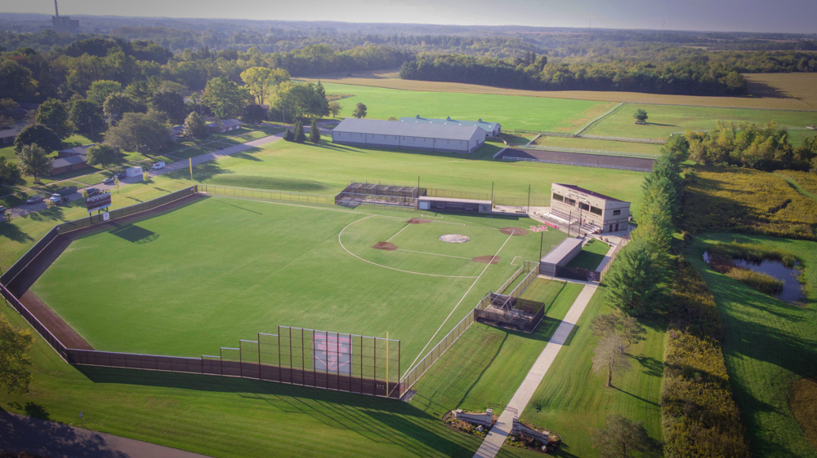
Sadler Stadium-A $5 million on campus baseball stadium including a 119,000 sq ft all synthetic turf playing surface.

COST
Cost for the camp is $60 if you pre-register ($100 walk-up or after August 9, 2025). The fee includes a camp T-shirt, quality instruction and evaluation. Cash is preferred but check or money orders are accepted. Credit cards accepted only online. Please make checks payable to: Earlham College Baseball Camps.

GENERAL INFORMATION
EARLHAM COLLEGE BASEBALL
Prospect Camp Registration Form

Player’s Name: ________________________________
High School__________________________________
Grade___________ Age: ________
Position(s) 1._____2._____ Throws______ Bats______
Height________ Weight_______
Date of Birth: _______________
Players’ Email_________________________________
Cell_________________Phone___________________
Parents’ Names________________________________
Parents’ Email_________________________________
Address: _____________________________________
City: __________________ State: _____ Zip: _______ Contact Number: __________________________
T-Shirt Size: S____M____L____XL___

Agreement and Release of Liability
I and my heirs release Earlham College and all its employees, officers, and agents from liability for damages to or loss of any personal property, sickness and injury from whatever source, legal entanglement, imprisonment, death, loss of money, etc. for which the college is not liable which might occur participating in this camp. I also authorize Earlham College to provide the necessary medical care if needed.

Signature: ____________________________________

____________________________________________
Parent or Guardian Signature (if under age 18)

Mail this section to: Sign up online:
Earlham College Baseball earlhambaseballcamps.com
Attn: Steve Sakosits
801 National Rd West
Richmond, IN 47374

The camp is open to players who will be graduating from High School in 2026 through 2027 and who have a strong desire to play college baseball. The camp has a limited enrollment so sign up early. Don’t miss out on the opportunity to improve your game and learn more about what it takes to play baseball at the college level. Also enroll at www.Earlhambaseballcamps.com

CAMP STAFF

- Steve Sakosits-Head Baseball Coach
- Blake Peterson-Pitching Coach
- Brandon Wilson-Hitting Coach
- Brandon Pennington-Base Stealing Coach
- Pat Flanagan-Asst Pitching Coach
- Kevin McGee-Asst Baseball Coach

Want to register online or pay with a credit card?

Go to:

www.earlhambaseballcamps.com



